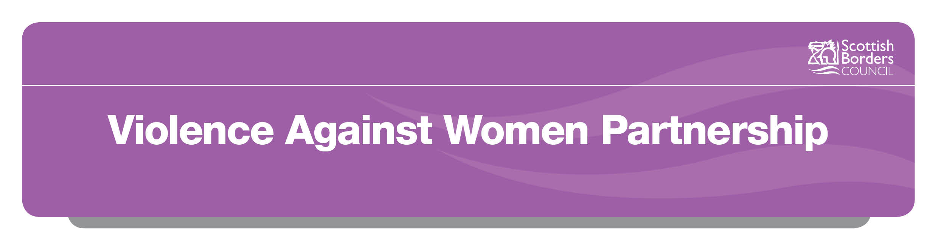**Scottish Borders Violence against Women Partnership Award 2018**

The Scottish Borders Violence against Women (VAW) Partnership Award 2018 has been developed in order to recognise the commitment and excellent work of individuals in our communities who have made a significant contribution to addressing violence against women/girls in the Scottish Borders.

The VAW Partnership collectively agreed that there should be some way to recognise these efforts, and that “partnership” also includes communities. This is the second award with the previous winner representing Scottish Borders Rape Crisis Centre, working as a volunteer.

Audrey Laycock was the first winner in 2015 of the Scottish Borders Violence against Women Partnership Award. Audrey was recognised for her role as a volunteer support worker at Scottish Borders Rape Crisis Centre (SBRCC) since it was established in 2010. She also volunteered to work with children and young people in the CEDAR Groupwork programme (Children Experiencing Domestic Abuse Recovery). Audrey has supported many survivors and is a very skilled and knowledgeable volunteer. She has a deep understanding of the impact of gender-based violence on survivors, their friends, families and the wider community. Audrey through her volunteering provides a safe, non-threatening environment where women and girls can talk freely and in confidence.

We are delighted with the sponsorship by Berwickshire Housing Association for the 2018 award; they have been a very active partner in tackling violence against women in the Scottish Borders

**How to enter**

A short submission of approx. 500 words is required to describe why you think the individual (nominee) deserves the recognition. The nominee must consent to the nomination but we are looking for **your** views on the contributions made, giving examples where you can? Please see attached for the Nomination Form.

Anyone can nominate an individual who could be a worker, a volunteer, a community member, public figure, or someone who represents a group e.g. youth group.

Nominees must be aged 16 years or over.

Once you have completed the Nomination Form you should submit it electronically to

Louise MacLennan, VAW Executive Group Chair:

* [louise.maclennan@sky.com](mailto:louise.maclennan@sky.com)
* Louise MacLennan, 27 Ladylands Terrace, Selkirk, TD7 4BB.

Alternatively you can complete, print off and hand into Scottish Borders Council, Newtown St Boswells for the attention of Andrea Beavon, VAW Coordinator.

**Closing dates for nominations is 30 September 2018.**

**What happens next?**

After the closing date, a panel of volunteers selected from the VAW Partnership will read all the nominations and create a shortlist. From this, only one nominee will be selected to receive the Award. The panel will be looking for the following to make their decision:

* Type of activity undertaken by the nominee
* Who does the activity benefit – adults, children, families, the wider community?
* Do they go the “extra mile” – how do they do this?
* What is the added value of this individual’s contribution?
* Does the activity empower people?
* Does the activity challenge societal inequality or raise awareness of violence against women?
* Are there examples of how this individual has significantly contributed to the VAW agenda in the Scottish Borders?

The Award winner will be contacted directly by the Chair of the VAW Executive Group to inform them of the result.

The winner will be invited to attend a small Awards Ceremony on 26 November 2018 at Council Headquarters. All those nominated will be invited to attend the ceremony as well. There will be some publicity for the event, with a press release.

**Terms and conditions**

* Nominees must consent to the submission
* Nominees must be aged 16 or over
* Nominees must be resident or working in the Scottish Borders
* Nominations must describe activity that addresses violence against women and girls specifically
* Nominations must clearly indicate whether a nominee is representative of an organisation or being nominated in their own right
* Nominations will be accepted for both women and men

**SCOTTISH BORDERS VIOLENCE AGAINST WOMEN PARTNERSHIP AWARD 2018**

**NOMINATION FORM**

Name of Nominee:

Address of Nominee:

Telephone Number of Nominee:

Email of Nominee:

Do you have their consent to nominate them? Yes/No

Name of Nominator:

Address of Nominator:

Telephone Number of Nominator:

Email of Nominator:

Why have you chosen to nominate this person/organisation for the Violence Against Women Award 2018? (please use a maximum of 500 words and give examples where possible?)

***Please submit your completed form electronically to Louise MacLennan, VAW Executive Group Chair at:*** [***louise.maclennan@sky.com***](mailto:louise.maclennan@sky.comL) ***or by post to 27 Ladylands Terrace, Selkirk TD7 4BB****.*