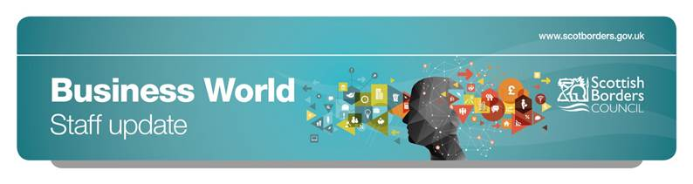

**Business World in Focus | September 2017**

This update is specifically focused on helping to address a workflow bottleneck that is preventing us paying our suppliers in a timely manner.

At present we are being prevented from paying certain invoices due to having received the invoice for goods/services the Council has received, yet there has been no Goods Receipting done or the Goods Receipting has been done after the invoice is received without using the ‘Purchase Inv - Missing Goods Receipt Task’ link to perform the receipting.

The following information highlights a few key things that need to be done so that we can address and avoid this situation.

**Goods receipting in Business World**

Missing Goods Receipt Tasks will only be generated if the Goods Receipting has not already been done when the goods/services are received rather than when the invoice is received into the Council. Therefore it is best practice, wherever possible, to get the purchase order goods receipted at the point of receiving the goods/service rather than at the point of invoice receipt.

Goods Receipting needs to be accurate as this is one of the aspects of the three way match of invoice to order to goods receipt that triggers authority to pay. Specific Guidance on this is available at the [Business World Intranet Page](http://intranet.scotborders.gov.uk/yourjob/Pages/business-world.aspx)

**Dealing with missing goods receipt tasks**

There are, however, instances where it is appropriate to wait for the invoice to be available before the services are receipted in Business World and in these situations it must be done through the system generated Missing Goods Receipt Task.

The [Dealing with Missing Goods Receipt Tasks](http://intranet.scotborders.gov.uk/IntranetContent/Dealing%20with%20Missing%20Goods%20Receipt%20tasks.docx) document on the intranet explains the process of receipting goods/services when the receipt of an invoice triggers a Missing Goods Receipt task.

**It is crucial to the prompt payment of suppliers that these tasks are performed in accordance with this guidance and in a timely manner.**

A simple rule for Business World is that you should always do ‘Your Tasks’ first rather than use the menus on the left hand side of the screen. This is also the quickest way to get to the correct screen for the task required and follows the correct workflow rules required for the tasks to be processed efficiently. Your Tasks can be found in the area highlighted with the red circle below.

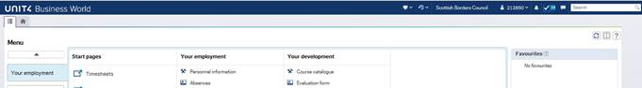

By Clicking on the ✓ in the red circle are highlighted above, this will then take you will to ‘Your Tasks’ which displays similar to that shown below. In this example, the Missing Goods Receipt task relating to progressing the payment of invoices has been highlighted and can be accessed by clicking on the task name.

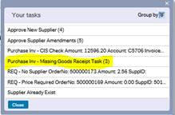

**Original requisitioners no longer in post**

A significant number of Missing Goods Receipting tasks that are outstanding are due people who have left the organisation or moved to new roles. Although we are in the process of creating the appropriate procedures to capture this information and respond to this, we do need information from line managers to redirect workflow tasks. It would be greatly appreciated if line managers of anyone who has raised requisitions and has moved on from the position that was related to raising the requisition sends the following information to the [Business World Mailbox](mailto:businessworld@scotborders.gov.uk)

|  |  |  |
| --- | --- | --- |
| **Leaver Details** | **Employee Number** |  |
| **Employee Name** |  |
| **Position Number** |  |
| **Position Name** |  |
| **Replacement for Requisition Tasks** | **Employee Number** |  |
| **Employee Name** |  |
| **Position Number** |  |
| **Position Name** |  |

This will allow us to redistribute the task and get the invoice paid.

**Remember**

* If you manage staff with no IT access, can you please ensure that they get access to this update and know where to find [previous versions](https://www.scotborders.gov.uk/downloads/download/665/business_world_information).
* You can also find out more at: [www.scotborders.gov.uk/BusinessWorld](http://www.scotborders.gov.uk/BusinessWorld) and [check out our FAQs](https://www.scotborders.gov.uk/downloads/download/665/business_world_information).

Regards,

Business World Project Team

w: [www.scotborders.gov.uk/businessworld](http://www.scotborders.gov.uk/businessworld)

e: [businessworld@scotborders.gov.uk](mailto:businessworld@scotborders.gov.uk)