CLOICH Forest
Tree felling operations, see red area on map!

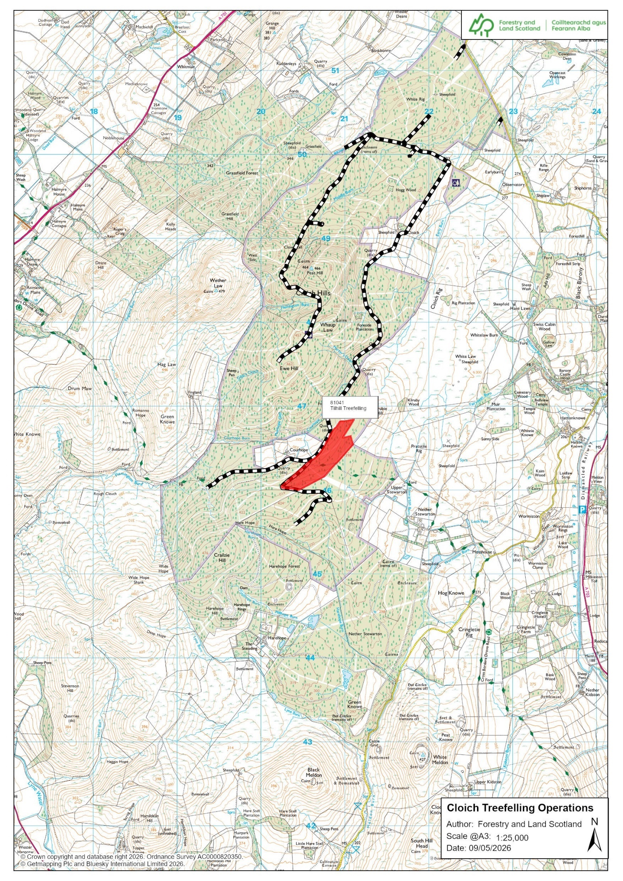
Monday to Fridays: From Tuesday 12.05.2026 – Wednesday 27.05.26 Live operations on Cross Borders Drove Road in tree felling area (red on map). No through access.

Forest Road adjacent to felling area, see map: Tree stacking and timber haulage operations.
Get operators attention and wait for signal to pass safely!

No access 7 days a week.

Felling is due to finish end of July 2026.

Expect timber haulage along forest road.

We are sorry if these operations affect your plans today.

Monday to Fridays: From Tuesday 12.05.2026 – Wednesday 27.05.26 Live operations on Cross Borders Drove Road
in red zone. No access!

Forest Road: Live operations
Get operators attention and wait for signal to pass safely!



Tel:

0300 067 6900 forestryandland.gov.scot

