

Supporting Statement
for
Jedburgh
Local Place Plan

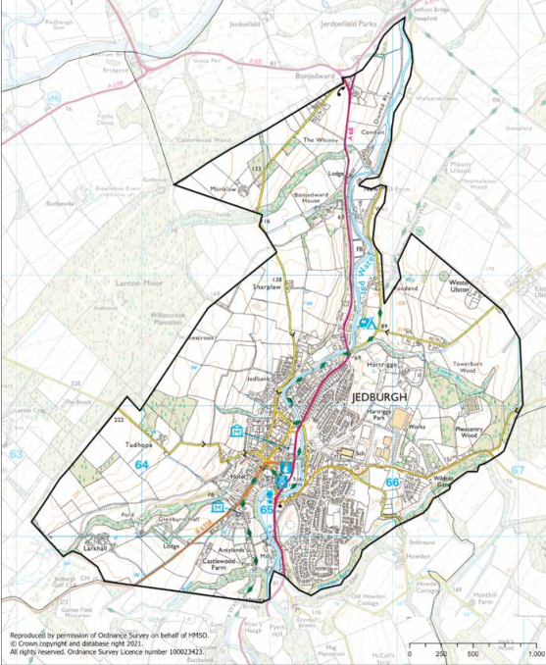

Prepared by: Jedburgh Town Team
Date: 10/12/2025
Contents
Item | Page Number
Introduction | 1
Contact details | 2
Regard given to the Local Development Plan | 2
Regard given to the National Planning Framework | 3
Regard given to the Locality Plan | 4
Reasons for amendments being sought to the Local Development Plan | 4
Community support for the Local Place Plan | 4
Evidence of compliance with Regulation 4 | 5
Appendix | 5

Introduction
This Supporting Statement forms part of the Local Place Plan submission to Scottish Borders Council and is accompanying the Jedburgh Local Place Plan dated 08/04/2025
For Jedburgh, community comes first and foremost, and this Place Plan lays a course for shaping
our future. It has been researched and produced by local volunteers working in partnership with local people via the Town Team and supported by Scottish Borders Council and South of Scotland Enterprise.
The Place Plan looks ahead at ways to attract and encourage inward investment and open the door to new opportunities and deliver change. It works hand-in-hand with key local, regional and national policy objectives found in National Planning Framework 4 and the Scottish Borders Council Local Development Plan, whilst embracing ideas and aspirations submitted by the community at a programme of consultation events and community conversations.
Improving all aspects of quality of life is at the heart of Jedburgh’s Place Plan and the community stands ready to write a new chapter of success for the town.
Our plan aligns with the Borderlands Inclusive Growth Deal, ensuring that our efforts are supported by a broader regional strategy aimed at fostering inclusive economic growth and sustainability.
AtkinsRealis was commissioned to support the Town Team with the “polishing up” of the Place Plan so that the forthcoming Town Investment Plan can be fully informed by the community led process.
This Community led Place Plan seeks to stimulate local life and enhance Jedburgh’s standing through the delivery of an enterprising and creative programme in the key areas of:-
• The local economy and inward investment
• Protecting heritage and promoting the town’s tourism offer
• Enhancing the local environment and town centre
• Supporting first class education, leisure and lifestyle activities

Contact details
Jedburgh Community Council are submitting the plan on behalf of the Jedburgh Town Team.
Jedburgh Community Council Email address: jedburghcommunitycouncil@outlook.com
Jedburgh Town Team Email address: jedburghtownteam@outlook.com

Regard given to the Local Development Plan
Our Local Place Plan (LPP) for Jedburgh aligns with National, Regional, and Local policies to create a vibrant, resilient, and sustainable community. By integrating principles from the National Planning Framework 4 (NPF4), the Scottish Borders Local Development Plan (LDP) 2, and the Borderlands Inclusive Growth Deal, our plan aims to enhance the quality of life for residents and make Jedburgh an attractive destination for visitors. Below is a detailed alignment of our plan with these policies.
Scottish Borders LDP 2
The Scottish Borders Local Development Plan (LDP) 2024 identifies much of our town as a conservation area and highlights key greenspaces such as Jedforest Bandstand, Allerley Well Park, and Howden Park. It also zones land in the east of our town for housing and business development, including sites like the Port House and Jedburgh Grammar School for redevelopment.
Our Place Plan aligns with the LDP’s land zoning proposals by:
• Conserving Key Buildings: Proposing the creation of an Events Quarter and a Creative Quarter with the retention of the Port House and modernisation of the facilities in the Town Hall , aligning with the LDP’s focus on conservation.
• Housing Development: Highlighting the need for more affordable housing, identifying sites like the Grammar School site for redevelopment.
• Green Networks: Advocating for a cycle/multi-use route between Jedburgh and Ancrum to other path networks within the Borders, increasing active travel networks and tourism and overnight stays.
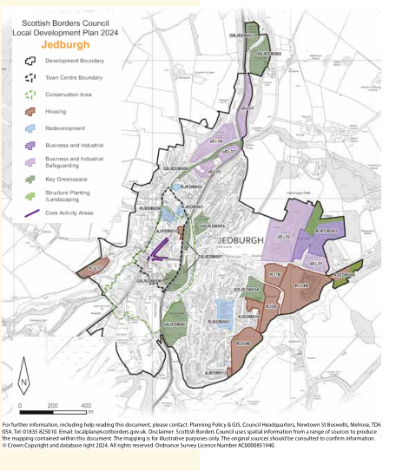

Regard given to the National Planning Framework
Our Local Place Plan (LPP) aligns with the National Planning Framework 4 (NPF4) in several key areas by:
• Liveable Places: Enhancing local availability of goods and services by encouraging the creation of amenities within town centre gap sites, increasing amenities within a 20-minute walk distance.
• Productive Places: Focusing on reusing buildings in Jedburgh to create more local businesses and promote community wealth building, providing more jobs for local people and making Jedburgh a desirable place to live and work.
• Advocates for increased visitor accommodation to boost the local economy and jobs through tourism.
• Rural Revitalisation: Sustaining and growing the rural community by providing more goods and
services locally.
• Sustainable Places: Supporting climate mitigation and adaptation by refurbishing and reusing existing buildings, and highlights our aspirations around sustainability and decarbonisation for all of our projects.

Regard given to the Locality Plan
Whilst preparing the Jedburgh Place Plan, the Cheviot Locality Plan 2020 was taken into account. The Locality Plan outlines priorities for the Cheviot area with a focus on reducing inequalities to improve the area for those who live, work and visit the area.
The Plan is structured around the key themes of:
- Our Economy, Skills & Learning. Key priorities included improving rural digital connectivity and improving the reliability and accessibility of transport services.
- Our Health, Care & Wellbeing. Key priorities included increasing the range and accessibility of community activities to encourage a reduction in drug and alcohol use.
- Our Quality of Life. Key priorities included creating safe areas for young people within local communities and provide leisure facilities that are accessible and affordable.
- Our Environment & Place. Key priorities included creating appropriately placed, affordable and socially inclusive housing in the countryside, and developing attractions within the countryside to encourage visitors to the area.
- The development of the Jedburgh Local Place Plan, and projects therein, considered and had close regard to the Cheviot Locality Plan.

Reasons for amendments being sought to the Local Development Plan
The Jedburgh Place Plan does not set out definitive allocations (new or amended), nor definitive policy changes, to the Local Development Plan (LDP). However, the Jedburgh Place Plan should be considered during the forthcoming LDP process once registered as a Local Place Plan. The Jedburgh Place Plan sets out several projects and proposals for the development or use of land and reuse of buildings, supported but the community, which are to be implemented over time. The projects and proposals, in principle, are complementary to the LDP rather than competing, conflicting or opposing, and set out how the community would like to see these developed.
The projects and proposals are presented on pages 68 to 77 of the Jedburgh Place Plan.
Community support for the Local Place Plan
Evidence of community support for the Local Place Plan can be found in section 5 pages 40 – 57 and Appendice pages 86 – 93 of the plan.

Evidence of compliance with Regulation 4
The proposed Local Place Plan and information notice were sent on 12/12/2025 to:

List of Councillors to whom the proposed Local Place Plan was sent
- Cllr. Sandy Scott
- Cllr. John Bathgate
- Cllr. Scott Hamilton

List of Community Councils to whom the proposed Local Place Plan was sent
- Oxnam Water
- Jed Valley
- Lanton
- Crailing, Eckford and Nisbet

Appendix

Jedburgh Local Place Plan:
https://www.jedburghcommunitycouncil.com/a-place-plan-for-jedburgh.html

