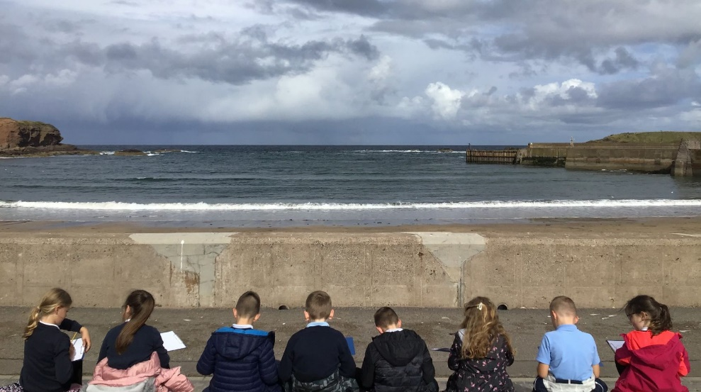



Eyemouth Primary School
School Handbook
2026/27

www.eyemouthprimary.co.uk

Contents

Visitors 22
School uniform 23
Transitions 23
School transport 24
School trips 24
School meals 24

Terms & Attendance
Terms and holidays 25
Attendance 26
Absence 26
Holiday Absences 27

Medical Care
Medical examinations 28
Medicines 28
Communicable diseases 29

Policies & Procedures
School Improvement Plan & Priorities 30
Health and Safety 30
Emergency closure of the school
/ adverse weather 31
Images of Pupils 33
Security 33
Use of the Internet 33
Policies 33

Child Protection
Keeping our children and young
people safe in the Scottish Borders 34

Young Carers 35

Data Protection 36

Complaints & Disclaimer 37
Welcome
Letter from the Headteacher 3
School Information 4
Staff 5
Vision, Values & Aims 6
Contacting the School 7

Learning & Teaching
Entitlements 7
The Curriculum 7
How does Curriculum for
Excellence work? 8
Physical Education 8
Active Schools 8
Home learning 8
The wider curriculum 9
Assessment 9
Summative Assessment 9
Formative Assessment 9
Reporting 10
Parental Consultations 10
Showbie 10
Play 11
Inspire Learning 12
Enrichment 13
Healthy Beginnings 14

Support for Learning
Support for Learning 15
The Educational Psychology Service 15
The Zones of Regulation 16
Council’s implementation of
British Sign Language Plan 17
Closing the Attainment Gap 17
Getting it right for every child 18
Promoting Positive Behaviour 19

Partnership with Parents
Parent Council 20
Communicating with home 21

How our school works
Enrolment 22
Arriving & departing 22

Welcome



Dear Families,
Eyemouth Primary is a school where individuals are valued and helped to be the best they can be. Children are supported in becoming confident and independent young people, who thrive on challenge, and are motivated to learn.
The excellent start begins in the Early Learning Centre (ELC) and continues through the school with staff providing a safe, happy, supportive and purposeful environment, and a curriculum that excites and stimulates children’s imaginations and creative thinking. The curriculum is delivered through a cross-curricular approach which is further enhanced by whole-school themed days and weeks to promote enquiry-led learning.
I am extremely proud to lead this team, who are committed to children's well-being, achieving high standards and providing the very best opportunities for all in our care.
Mrs Jill Horsburgh
Headteacher
Eyemouth Primary School



Contact Details

School Information
Eyemouth Primary School
Coldingham Road
Eyemouth
TD14 5AN

Telephone Number: 018907 50692

E. Mail: eyps@scotborders.gov.uk

School Website: www.eyemouthprimary.co.uk

Headteacher: Mrs J Horsburgh

School Roll: 310 including 33 ELC at September 2026

No of Classes: 12 – ELC – Primary 7

Stages Covered: ELC – Primary 7

Eyemouth Primary is a non-denominational school catering for all pupils, both boys and girls, aged 2 – 11.

SCHOOL DAY TIMES
Our Eyemouth Primary School Early Learning and Childcare Hub (ELC) is open between the hours of 8.00am to 6.00pm Monday to Friday.
PP1 – P7E ELC SESSIONS DAY TIMES
10:30 –Lunch: 12:10 – 12:50 (P1-P3)

Primary 1 to 7 Monday to Thursday

Start: 08.50 (8.45am for P1)

Break: 10.30 – 10.45 (P1, P2. P2/3, P3/4 and P4)

Break: 10.45 – 11.00 (P4/5, P5, P6, P6/7 and P7)

Lunch: 12.15 – 12.55 (P1)

Lunch: 12.15 – 12.55 (P2 and P2/3)

Lunch: 12.20 – 1.00 (P3/4 and P4)

Lunch: 12.40 – 13.20 (P4/5 P5, P6, P6/7 and P7)

Finish: 15.10 for P1s & P2 – 7 15.15

Primary 1 to 7 Friday

Start: 08.50

Brunch: 10.00 to 10.30am P4/5, P5, P6, P6/7 and P7

10.30 to 11.00am P2, P2/3, P3/4 and P4

11.40 to 11.10am, P1

11.20 – 11:50 noon ELC

Finish: 12.15pm for P1s &12.20pm P2 – P7

10 (P4-P7RID
Staff

AY (for P1 – P7 Pupils)

HEADTEACHER
Mrs J Horsburgh
DEPUTY HEADTEACHERS
Mr S Agnew & Mrs E Hiroz

CLASS TEACHERS
Ms A O’Malley P1A
Mrs H Burns P1B
Mr T Crawford P2
Miss T Dewar P2/3
Miss S Philp P3/4
Miss E Burgher P4
Mr A Taylor P4/5
Miss R Easson P5
Mr G Fryer P6
Mrs E Craig P6/7
Miss S Paterson P7

PUPIL SUPPORT TEACHER
Miss T Renton

CURRICULUM SUPPORT
TEACHER
Mrs V Royan (PE)

NURTURE SUPPORT TEACHER
Mrs D Knighton

EYEMOUTH CLUSTER ADMIN ASSISTANT
Mrs H Blackie

BUSINESS SUPPORT ASSISTANTS
Mrs J Buchan
Mrs A Surridge

HOME SCHOOL LINK WORKER
Miss Laura Simm

SENIOR EARLY YEARS OFFICER

ELC PRACTITIONERS
Miss L Blackie
Mrs K Hogarth
Miss Halle Simpson
Miss Holly Simpson
Ms M Downs
Miss Z McCraw
Miss G Finlayson

EARLY YEARS CENTRE STAFF
Mrs T Moffat, EYC Manager

PUPIL SUPPORT ASSISTANTS
Mrs C Coates
Mrs J Macrae
Mrs A Houliston
Mrs K Moscrop
Mrs L Purves
Miss S Strang
Mrs L Tansey
Mrs A White
Mrs M Windram
Miss L Younger

COOK IN CHARGE
Mrs E Stevenson

ASSISTANT COOK
Mrs J Pringle

GENERAL ASSISTANT
Mrs V Pringle
Mr G Smith
Mrs K Murray

JANITOR
Mr R Macfarlane

Ms C Wardhaugh

EARLY YEARS OFFICER

Mrs L Watson

Our Vision Statement:

Together in a safe learning environment, we respect each other and achieve success.

Our values are:

Ready, Respectful, Safe.
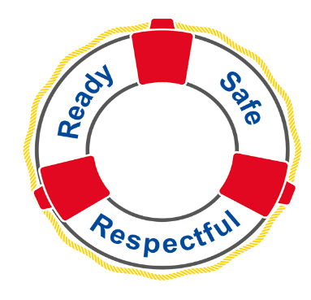

Our school aims are:

- Everyone is ready to welcome new opportunities in their learning and through wider experiences.
- Everyone will respect each other, their diversity and the environment.
- Everyone will feel safe and supported in an inclusive community.
- Everyone’s health and well-being at Eyemouth Primary School will be our priority.
Our school Motto is:
From the sea to the stars, be the best you can be!


CONTACTING THE SCHOOL
If you have any queries or concerns please do not hesitate to get in touch with us. If you feel an appointment with a teacher or Headteacher is required please telephone the school office and a mutually convenient time will be arranged.

We communicate with parents in a number of ways:
• Reading diaries
• Telephone calls/Emails
• Newsletters
• Showbie/reports and parental consultations

In our efforts to be more eco-friendly we are trying to send information home electronically where possible.
Parents are asked to provide an email address when enrolling their child.

Learning & Teaching

At Eyemouth Primary, we foster an environment where our pupils become active participants in their learning. Education should not be passive but an exciting, fun and challenging time in a child’s life. We aim to give children a breadth of experiences and a hunger for knowledge, equipping our young people with skills they will take to the world of work and life. A Curriculum for Excellence, published in 2004 following the National Debate on Education in Scotland, sets out values, purposes and principles to enable children and young people to reach their full potential. At Eyemouth we have fully embraced the guidance in these documents to improve the quality of learning and teaching as well as increasing attainment and achievement for all children, including those who need additional support in their learning.

Entitlements
• All learners are entitled to experience the highest possible quality of learning and teaching that prepares them effectively for learning, work and life.
• All learners are entitled to experience learning and teaching that supports them in becoming literate, numerate and healthy.
• All learners are entitled to experience learning and teaching that promotes equal opportunity and non-discrimination based on social circumstances, gender, race, religion, cultural beliefs, disability or sexual orientation.
• All learners are entitled to opportunities and encouragement to participate to their maximum potential and to be consulted and involved indecisions affecting their learning.
• All children are entitled to become successful learners, confident individuals, effective contributors and responsible citizens through the values and principles of Curriculum for Excellence.

The Curriculum
Curriculum for Excellence (CfE) is bringing learning to life in the way education is delivered for all 3-18 year olds – in ELC, primary, secondary, at college, workplace or community learning. It takes a fresh approach to what, how and where young people learn. It aims to raise standards, improve knowledge and develop skills, closing the gap between the lowest and highest performers. Ultimately, it aims to nurture young people as successful learners, confident individuals, effective contributors and responsible citizens.

At Eyemouth Primary School we aim to:

• Establish a safe, secure and stimulating learning environment where everyone is respected and valued.
• Ensure that pupils are active participants in their own learning and can confidently identify their strengths and what they need to do to improve.
• Use a variety of informed, differentiated teaching approaches which take account of prior learning and are matched closely to individual needs.
• Develop learner’s curiosity, creativity and ability to think critically through well-planned tasks which involve solving problems, working collaboratively and independently.
• Enable pupils to understand the purpose of their learning, make connections and apply their skills and knowledge to real life situations.
• Provide opportunities for children to develop confidence and resilience through personal success and achievement in our wider learning environment.
• Reflect upon and share our good practice to ensure inspiring learning and teaching continues to thrive.


How does Curriculum for Excellence work?

The ‘learner journey’ will be joined up from 3-18 to avoid gaps and overlaps in learning and to make the most of achievements outside school.
• Learners will work at a pace that suits, with enough challenge and support to stretch them.
• Lessons will be more engaging, inspiring and relevant to everyday life.
• Teachers will make connections between subjects, helping children
make sense of the world.
• Children will develop an understanding of how to learn and how to use their learning, not just memorise information to pass tests. This will help them adapt in an uncertain future with the ability to think for themselves, make sound judgements, challenge, enquire and
find solutions.
• There is more focus on knowledge and skills – including vital skills: literacy and numeracy, which underpin all learning and are critical in life.
• There are changes to assessment and how progress is reported to give
learners, parents and employers better information on potential and achievement.

Physical Education
  - At Eyemouth Primary School we have a PE Teacher in post to teach all pupils. Class teachers ensure that a further hour of PE is taught, where appropriate, so every child has the expected 2 hours of PE a week.
- Children are expected to wear appropriate clothing (see uniform)

Active Schools
The Active Schools team, run by Live Borders, are responsible for putting in place and driving forward a wide range of sports and activities in local schools and supporting the local communities, to provide children and young people the opportunities to participate in physical activity and sport.

Home learning
Children are provided with home learning opportunities which include regular reading, spelling and numeracy tasks. We make use of technology wherever possible to support learning at home with digital resources such as IDL and Magma Maths being used to develop skills in mathematics. Also, used Accelerated Reading is used to promote reading skills and Showbie is used as a platform to share homework tasks in P4-7 classes.

The wider curriculum
Extra-curricular activities
The school works closely with our Active Schools Coordinator, Kendal Patterson, to provide a wide range of after-school activities. Children have the opportunity to participate in a wide variety of activities both in school hours and at Shake & Wake and After School Clubs run by staff, these activities change term to term.

Inter-school sport is therefore encouraged, with school pupils usually taking part in hockey, rugby and dance festivals at different times of the year. The school believes in the importance of broadening and enriching the child’s learning experience and with this in mind, arranges outings whenever suitable opportunities arise (see School Trips, p22).

Assessment
Assessment is a vital part of learning and teaching. It should be an ongoing process and involve the learner making decisions about their next steps. This takes two forms, assessment that happens at the end of a block of learning that checks how much a child has understood (summative) and assessment that is continuous (formative).

Summative Assessment
This is used to check how successful the learner has been at the end of a piece of work. It is one way of gathering evidence for reporting to parents or measuring attainment. It is only valid when used alongside evidence gathered from formative assessment. Standardised assessments are also used when appropriate to gather evidence on a child’s progress in a curricular area. This reflects on their progress in comparison to a cross section of children of a similar age.

Formative Assessment
Pupils know what they are learning, how they will recognise if the learning has taken place and what steps they can take to bridge the gap between what they know and need to learn by this process. It is evident in many guises in the classroom and is an integral part of learning and teaching.

Some examples are outlined below:
• Learning Intentions and Success Criteria
• Wait Time
• Traffic Lights
• Thumbs Up
• Think, Pair, Share
• Share an Answer with the Group/Class
• Two Stars and a Wish
• Self and peer assessment

Assessment evidence allows teaching staff to track the progress children are making and to adapt their practice appropriately. Staff can then identify if a child is struggling for whatever reason and needs extra support. By the same token staff identify children making considerable progress and can consider ways to challenge the child and ensure progress is maintained. It is important that evidence gathered through assessment be used to improve learning and teaching in our school.
We are committed to involving learners and their parents in learning and to regularly report on progress they are making.

Reporting
Reporting takes many forms. It is used to both give feedback on achievements and next steps and to create an agenda for discussion. Discussions take place between children and their peers, their teacher and their parents. Listed below are examples of reporting procedures in place. Across the school year we use a variety of different ways of reporting. Some approaches involve individual learners while some will involve groups and classes. We know that as parents you value on-going information about your child’s progress.

Reporting Activities
- Parent Consultation meetings  - Homework/Shared Learning  activities  - Learning Portfolios on Showbie  - Showbie Class Pages  - Written reports  - Review meetings  - Interagency meetings  - Progress within additional support for learning plans  - ‘Meet the Teacher’ sessions  - School Concerts | - Class Assemblies  - Open Afternoons  - Wall displays showcasing learning  - ‘Stay and Play’ events  - Monthly Update letters  - Information events  - Curriculum workshops  - School website/ Facebook / Twitter  - Parent Council meetings

Whilst the above list outlines our key approaches to reporting, Class Teachers are always available at any time in the year should you wish to discuss your child’s progress, have any concerns or would like to discuss any aspect of your child’s learning.

Parental Consultations
Parents are invited twice a year to discuss their child’s learning with the class teacher. This is normally a 10 minute appointment in October and May, where the teacher will share progress and next steps and can answer questions. It may be necessary to arrange a further appointment if the discussion requires more time. Pupils who receive additional support can request an appointment with the Pupil Support Teachers, Miss Renton and Mrs Knighton. We would encourage parents with concerns or questions to request an appointment at any time in the year. We are always happy to meet.

Showbie
Showbie is a secure online learning platform where teachers and students can collaborate, share content, and use educational apps to supplement in-class learning. We use the app to share individual pupil achievements in their Portfolio, report on progress in learning and we use the Class Group to share whole class achievements and information with parents/carers. Each year you will be given 2 codes which provide you with access to your child’s portfolio and their Class Group Page.



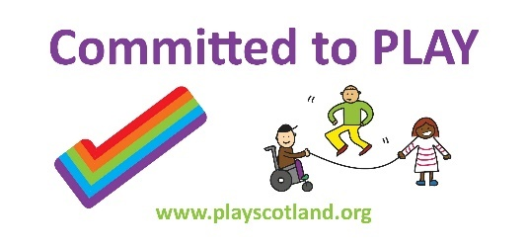

Play
Playing is an integral part of children’s day at School and in the Early Years. Children play before the bell goes in the morning; at playtime and lunchtime; and after school ends. Increasingly, playing is part of class time across Scotland too. At Newtown Primary School we recognise the interconnections between playing, learning, growing, developing, being healthy and being happy.

Why we place importance of play in our curriculum
Play empowers children to learn at their pace through active learning, developing;
- independence -emotional intelligence
- critical thinking -self-confidence
- logic -resilience
- cooperation -development of oral language
- participation -conflict resolution

Through play our learners experience all 4 contexts for learning; curriculum areas and subjects, interdisciplinary learning, ethos and life of the school, and opportunities for personal achievement.

We are delighted that all staff at Eyemouth Primary School are play champions. This means we are committed to support children’s right to play. Play Champions are professionals and individuals who uphold children’s right to play and commit to strategies and policies that support play.

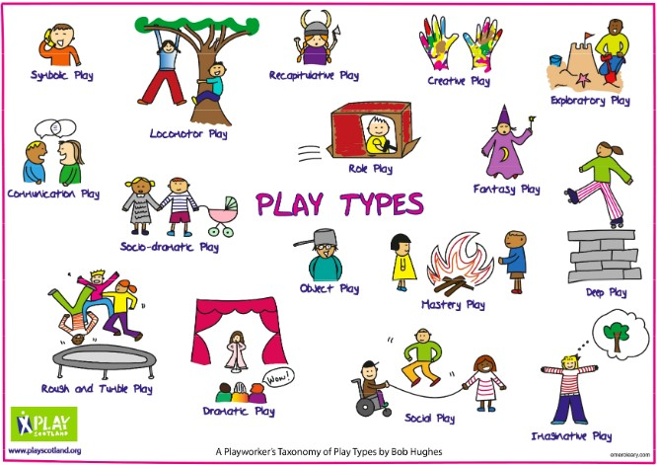

Inspire Learning
The Scottish Borders Council (SBC) Inspire Learning programme is an ambitious programme to ensure all children are equipped with high quality digital resources and learning. The aims of the programme are to:
• Raise educational attainment
• Provide equality of opportunity for all pupils
• Create a pupil centred curriculum which will provide engaging pupil-centred lessons
• Enable children and young people access to the most up to date educational resources
• Raise levels of engagement, motivation and interaction
• Improve facilitation of different learning styles
• Support remote and/or independent learning
• Improve self-management • Improve the digital skills needed for the future workplace

All children in P4 – P7 have their own iPad and children in P1 – P3 have access to a large supply to support their learning in school. We make regular use of digital technology across the school to enhance learning and teaching.


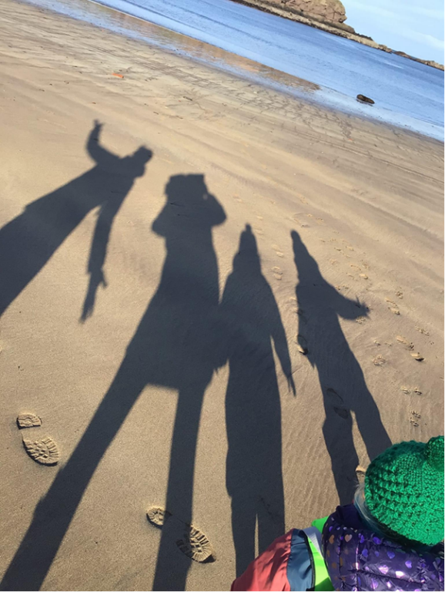

.

Enrichment at Eyemouth Primary
Enrichment in schools refers to the provision of additional learning opportunities beyond the standard curriculum, aimed at enhancing children’s knowledge, skills, and experiences. These enrichment activities can take various forms, including extra-curricular programs, special projects, competitions, field trips, visitors in school, and community events. Enrichment serves to challenge children, foster their talents and interests, and promote holistic development. At Eyemouth Primary School we valued enrichment across our school and the numerous benefits for our children.
Benefits of Enrichment:
- Enhanced Learning Experience: Enrichment activities provide children with hands-on experiences and real-world applications that deepen their understanding of academic subjects.
- Promotion of Critical Thinking: Enrichment activities often involve problem-solving tasks, creative projects, and analytical challenges, which stimulate critical thinking skills.
- Individualised Learning: Enrichment programs can be tailored to children’s interests, abilities, and learning styles, allowing for personalised learning experiences.
- Development of Talents: Enrichment opportunities enable children to explore their interests, uncover hidden talents, and develop expertise in specific areas, fostering a sense of achievement and self-confidence.
- Preparation for Future Success: Engaging in enrichment activities equips children with valuable skills such as teamwork, leadership, communication, and resilience, which are essential for success in higher education and the workforce.
Examples of Enrichment at Eyemouth Primary School:
At Eyemouth Primary School we aim to provide many opportunities for enrichment. These include enhanced learning experiences, the development of critical skills, and the exploration of interests and talents. We aim to provide providing diverse enrichment opportunities to inspire our children to reach their full potential and prepare them for success in the future. Some examples include:

- After School and Lunch Clubs: We have a variety of different clubs available over the year including School Choir, Hockey and Netball Clubs.
- Expressive Arts: We plan for a variety of Expressive Arts activities that incorporate visual arts, music, drama, and dance, allowing our children to explore their creativity, express themselves artistically, and participate in performances and exhibitions.
- Play: We recognise the interconnections between playing, learning, growing, developing, being healthy and being happy and provide regular opportunities for play across the school day.
- Outdoor Learning: We ensure all our children receive regular outdoor learning as part of the key entitlements of our curriculum. We provide opportunities for them to engage in our local environment, learning about the natural world, eco systems, biodiversity, conservation and sustainable practices.
- Community Projects: Enrichment activities involving community service projects enable our children to make a positive impact on the Eyemouth community while developing empathy, leadership, and teamwork skills.


Healthy Beginnings
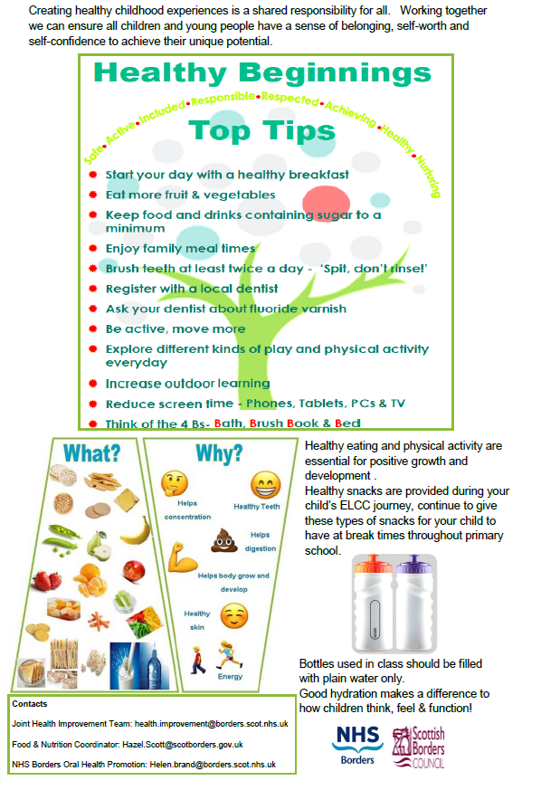

Support for learning
At any point in their lives children or young people may need extra help with their education. This may be for any reason and at any time. This is often referred to as additional support for learning or having additional support needs.

A child/young person’s needs may last for a short time, and the problem may be resolved easily or their needs might be very complex, and they may require additional support for a
number of years.

If you feel that your child needs additional support for learning, the first person to speak to is your child’s teacher. You have the right to request an assessment of your child. Within
our school we operate a model of staged intervention where support is provided in varied ways to meet individual needs. Our approach to assessment ensures that the needs of children and young people are recognised and appropriate support can be provided.

Parents/carers are always involved in making decisions about their child’s education and we will always ask your permission before any specific referrals are made. While your child is receiving support we will regularly review your child’s progress.
The statutory framework for Additional Support for Learning is the Education [Additional Support For Learning] [Scotland] Acts 2004 and 2009.

For more information, you can contact:
(a) Enquire, the Scottish advice service for Additional Support for Learning. They have a wealth of information, including practical guides and fact sheets for both parents/carers and

young people. You can find the website at www.enquire.org.uk, or call them on 0345 123 2303.
(b) Scottish Independent Advocacy Alliance, a charitable body registered in Scotland under registration number SC033576; www.siaa.org.uk
(c) Scottish Child Law Centre, a charitable body registered in Scotland under registration number SCO1274. www.sclc.org.uk
www.scotborders.gov.uk/info/886/additional_support_needs

The Educational Psychology Service
The Educational Psychology Service (EPS) works with all SBC schools to support children’s learning and wellbeing. We provide advice and training to school staff on how children learn, and advise on ways to help children who require support. If requested by the school, we can arrange follow-up for individual children and young people, together with their families and teachers, to help support their learning, or with social or emotional issues. This is generally achieved by meeting the children, their families and school staff, to review the support they have already received and agree ways in which we can all help your child in school. In some cases, we may agree that a psychologist will work on a one-to-one basis with your child to obtain a clearer picture of how they can best be supported.

If you have any worries about your child, please contact their school, in the first instance, to arrange a meeting to discuss your concerns. All schools have access to a range of support
Services and your child’s Headteacher will be able to advise you about when the EPS may be able to help.

Further information about the EPS is available on the Scottish Borders Council website. Here you can access a downloadable leaflet for parents and carers, which explains in more detail
how we may be able to work with you to support your child in school.

Please see www.scotborders.gov.uk/EPS

Zones of Regulation
The Zones of Regulation is a complete social-emotional learning toolkit created to teach children self-regulation and emotional control.

The Zone Colours
The Zones of Regulation uses four colours to help children self-identify how they’re feeling and categorise it based on colour. The toolkit also helps children better understand their emotions, sensory needs, and thinking patterns. They learn different strategies to help them cope and manage their emotions based on which colour zone they’re in. Additionally, the Zones of Regulation helps children recognise their own triggers, learn to read facial expressions, develop problem solving skills and become more attuned to how their actions affect other people.

The Green Zone
The green zone is used to describe when you’re in a calm state of alertness. Being in the green zone means you are calm, focused, happy, or ready to learn. This is predominantly the state all children like to be in. It’s also the state most needed in the classroom in order to learn.

The Yellow Zone
The yellow zone describes when you have a heightened sense of alertness. This isn’t always a bad thing, and you typically still have some control when you’re in the yellow zone. Being in the yellow means you may feel frustrated, anxious or nervous. But, it could also mean you’re feeling excited, silly, or hyper – which is okay in the right situations.

The Red Zone
The red zone describes an extremely heightened state of intense emotions. When a person reaches the red zone, they’re no longer about to control their emotions or reactions. This is the zone children are in during meltdowns. Being in the red zone means you’re feeling anger, rage, terror, or complete devastation and feel out of control.

The Blue Zone The blue zone, on the other hand, is used when a person is feeling low states of alertness or arousal. When you’re in the blue zone you may be feeling down – sad, sick, tired, or bored. You’re still in control, as you are in the yellow zone, but with low energy emotions.

Getting Back to The Green Zone
Along with being able to identify the zones, and know what zone they’re in, your child also needs to know strategies to help them get back to the green zone. Practicing co-regulation and self regulation strategies while your child is in the green zone will help them learn the best ways to get back there during times when they’re feeling stressed, frustrated, sad, etc

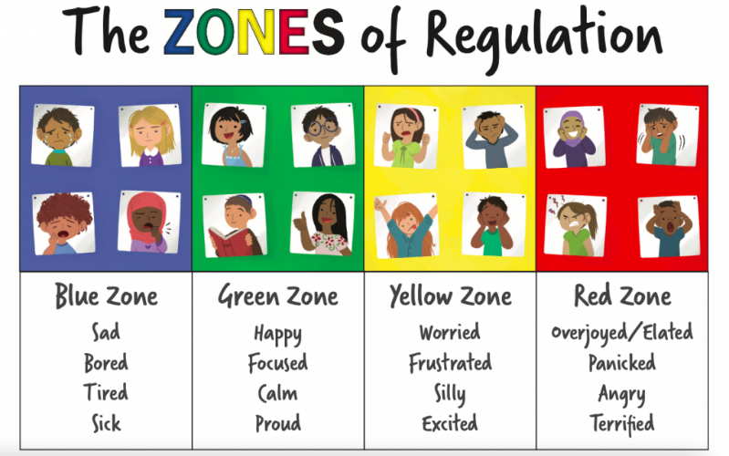

Council’s implementation of British Sign Language Plan

The Council’s BSL Plan 2018-24 has seven holistic actions. These actions are consistent with the ten long term goals of the National BSL Plan in Scotland, which are, early years and education; training and work; health, mental health and wellbeing; transport; culture and the arts; justice and democracy.

These goals represent the Scottish Government’s aim “to make Scotland the best place in the world for BSL users to live, work and visit.”

The Council will implement measures to promote awareness of BSL and the use of BSL, with the long term goal being that across Scotland information and services will be accessible to all BSL users*.

Contact Scotland –BSL is an online British Sign Language interpreting service that allows deaf people across Scotland to access services free and available 24 hours a day throughout the year: https://contactscotland-bsl.org/

If a BSL user requests a face-to-face meeting then the School is required to provide a face-to-face interpreter.

*Whenever we refer to ‘BSL users’ we mean D/deaf and /or Deafblind people (those who receive the language in a tactile form due to sight loss) whose first of preferred language is British Sign Language

To find out more about our National Education system follow the links below:
- https://education.gov.scot/
- https://education.gov.scot/parentzone
- http://www.skillsdevelopmentscotland.co.uk/

Closing the Attainment Gap
As part of our work central to the National Priorities for Scottish Education, we aim to ensure that there is ‘equity’ of provision so that all children may achieve their potential. This means that we ‘poverty proof’ school events, outings and After School activities to support families. Should any parent or carer feel they require financial support, or think they have an idea about how we could improve accessibility, please do not hesitate to contact the school to speak to any of the Senior Leadership Team or contact by email to:

eyps@scotborders.gov.uk

Getting it right for every child (GIRFEC)
Getting It Right For Every Child (GIRFEC) is the national approach in Scotland to
improving outcomes and supporting the wellbeing of our children and young people by offering the right help at the right time from the right people.

The GIRFEC approach aims to make it easier for parents, children, young people and the services that support them – such as early years services, schools and the NHS – to work together to get it right.

Practitioners work together to support you and your child, working across organisational boundaries and putting your child and you at the heart of decision making, ensuring we give all our children and young people the best possible start in life.

GIRFEC means that everyone working with Scottish Borders children, young people and their families are encouraged to:
- Ensure children, young people, and their families get the help they need when they need it and are central to the process of finding solutions.
- Use one consistent and equitable approach, actively share information to agreed protocols and work more effectively together to improve outcomes for children and young people.
- Be clear about personal responsibility to do the right thing for each child/young person.
- Work with children, young people and their families, using a collaborative approach with fewer meetings. This should ensure children, young people and their families give information only once, and enables the development of one plan to meet all their needs.
- Respond to children and young people and take appropriate, proportionate and timely action with the minimum of paperwork, bureaucracy and duplication.

GIRFEC is part of the Children and Young People (Scotland) Act 2014 and the GIRFEC provisions are planned to be fully implemented by August 2017. If you would like any further information please ask your child’s Headteacher.

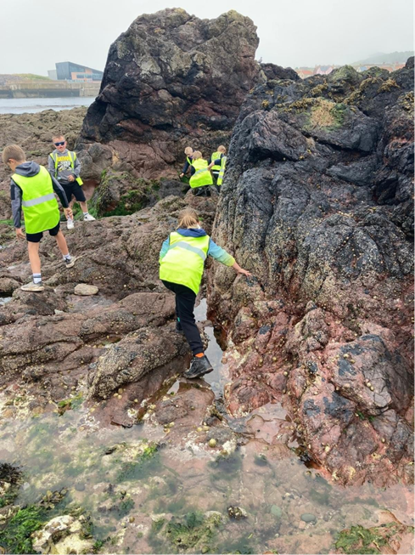



Promoting Positive Behaviour
At Eyemouth Primary School we aim to make positive behaviour the responsibility of all. We expect the highest standards of behaviour and look to achieve this through our engagement with the UN Convention of the “Rights of the Child”. This promotes a shared commitment to respect for all in our school and wider community. Using a common language we wish to ensure everyone can fully engage with our vision and treat each other with respect, understanding and empathy. We look to our pupils, parents and staff to be role models in displaying positive behaviour for all to follow. Through the use of restorative practices, as well as reflection and mediation, we aim to resolve any issues as quickly and positively as possible. Our approach is consistent, feels secure and is nurturing, forgiving and encouraging. We;
• have clear boundaries
• encourage learners to make good choices
• recognise positive interactions
• model positive interactions
• ensure there are logical consequences
• set reasonable expectations
• accept and move on ensuring that all situations can be resolved
• we teach learners about emotions
In Eyemouth Primary School strong relationships are at the heart of our school. These relationships include:
• Staff working with other staff.
• Staff and pupils working together.
• Pupils and pupils working together.
• Staff working with parents/carers and pupils

A Nurturing Approach
At the heart of our approach to positive relationships is our underlying whole school approach to Nurture. As a nurturing school, we recognise that positive relationships are central to both learning and wellbeing. A nurturing approach is based on the understanding of 6 Nurturing Principles, which have been adapted and are outlined below:

1. Children’s learning is understood developmentally
2. The environment offers a safe base
3. The importance of nurture for the development of wellbeing
4. Language is a vital means of communication
5. All behaviour is communication
6. Transitions are important in children and young people’s lives

Your child’s class teacher will deal appropriately with minor discipline problems in accordance with our positive relationship guidance. But if your child’s behaviour causes repeated disruption then a member of the Senior Leadership Team will become involved. If the problem continues we would invite parents into school to discuss further. It is vital that children see that home and school work together and we would hope that parents would support the school in any consequence given

The School follows Scottish Borders Council Respectful Relationship Policy – further information on this can be found at: www.scotborders.gov.uk/antibullying
Partnership with parents

Parents are encouraged to visit the school and participate in activities. Any parent who would like to help in the school should contact the Headteacher. Information is sent home, keeping parents informed of school events and activities as appropriate. This is normally by e-mail, unless parents have specifically requested correspondence by paper, but please continue to check your child’s bag regularly.

Parent Council
As Eyemouth Parent Council we hold regular meetings. Our meeting times are advertised through our school newsletters and on the Parent Council Facebook page. Everyone is very welcome to attend – you don’t have to be a member of the Parent Council to come along. These meetings are very informal and friendly.

Anyone can raise an issue for the Parent Council.

We are always looking for new ways to communicate with parents – please send us your good ideas.
Our role as a Parent Council is to:
• Act as a voice for all the families of Eyemouth Primary School
• Work in partnership with the school and community to give our children the best possible
education.
• Organise social and fundraising events.
Roles Include
Chair – Naomi Davie
Vice Chair – Jade King
Treasurer – Dani Fogg
Secretary – Mhairi Renton

Parent Members – there is no limit to the number of parent members we can have
Headteacher – Jill Horsburgh
Members of staff are welcome to join as well.

Contact email:
friendsofeyemouthprimaryschool@gmail.com or via
Eyemouth Primary Facebook page
@eyemouthprimary



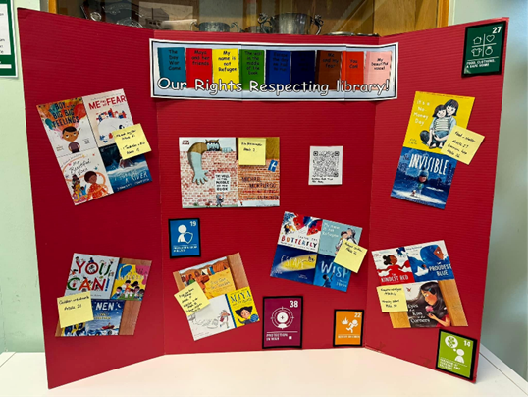

By law schools have a duty to promote parents’ involvement in children’s education. We are very keen that parents feel able to be involved in their child’s education and learning, that they are active participants in the life of the school and they feel able to express their views on school education generally. Every parent who has a child at our school is a member of the Parent Forum. The parent council is a group of parents who have chosen to represent the parent forum. As a member of the Parent Forum, each parent can expect to:

• Receive information about the school and its activities
• Hear about what partnership with parents means in our school
• Be invited to be involved in ways and times that suit you
• Identify issues you want the parent council to work on with the school
• Be asked your opinion by the parent council on issues relating to the school and education it
provides
• Work in partnership with staff
• Enjoy taking part in school life in whatever way possible
The type of things the parent council may get involved in include:
• Supporting the work of the school
• Gathering and representing parents’ views to the Headteacher, Scottish Borders Council
and Education Scotland
• Promoting contact between the school, parents, pupils and the local community
• Fundraising and organising events
• Reporting to the parent forum
• Being involved in the appointment of senior promoted staff.

Communicating with home
The school regularly sends information home to parents/carers by Groupcall/Eduspot with newsletters, leaflets and letters as attachments. Text messaging is also used to convey short urgent messages. Non-resident parents who request newsletters and reports should supply contact information and items will be emailed to them.

How our school works

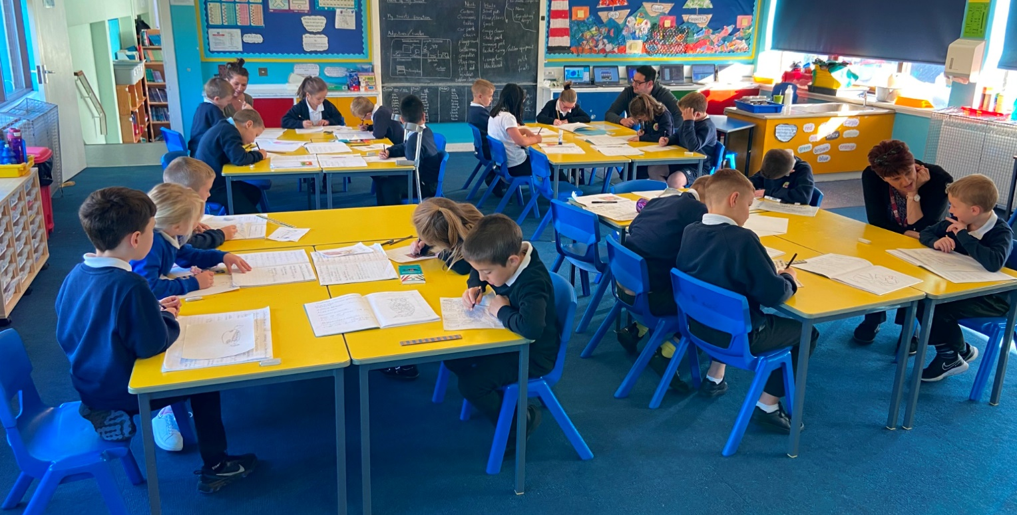

Children Arriving/Collected Late
• We understand that there are occasions where children may arrive late for school. Any pupil arriving late should enter the school through the main playground and up to the school office.
• If any parent is delayed at the end of the day their child/children will be asked to wait at the school office where parents
can collect them.

Visitors
• In the interests of security for all of the
children. All parents/visitors should enter the school through the main entrance.

Enrolment
Enrolment for Primary 1 takes place in
November. ELC enrolment normally takes place in January. Further information and enrolment forms are available from the School Office.

PLEASE NOTE: Parents living outwith the Eyemouth Primary School catchment area should access Scottish Borders Council Website, click on Schools and Learning, then apply for a school place and here you will find all the information on Placement Requests.

Arriving & departing
The Playground Supervisors are on duty from 08.35am. Parents should
ensure that pupils do not arrive before
this time.

Please inform the school if it is
necessary to change your arrangements to collect your child.
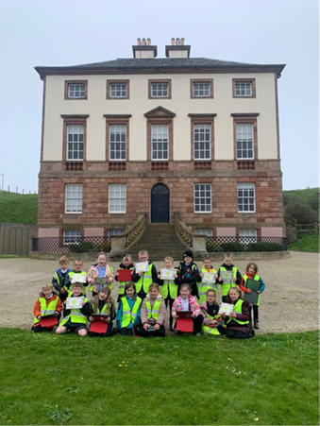

At Eyemouth Primary School we
actively promote the wearing of school
uniform. This has many practical
advantages relating to safety, cost and
appearance. The school maintains a
very high standard in this area. Parents
and children are actively encouraged to
support this.

Forms for financial assistance are
available on the Scottish Borders
Council Website.
The Agreed Dress Code for Eyemouth
Primary School is as follows:
(Uniform can only be ordered online from Border Embroideries, My Uniform or Fantasy Prints (Fantasy Prints have a shop in West Street, Berwick upon Tweed).

ELC
Nursery sweatshirts
Comfortable clothes

P1 –7 Boys
White polo shirt
Grey/navy/black trousers

P1 –7 Girls
White polo shirt
Grey/navy/black skirt or trousers

P1 – P6 Pupils
Navy School Sweatshirt, Cardigan/ Jumper in Navy Blue

All pupils are encouraged to wear black/
dark shoes or boots

P7 Pupils
Wear purple sweatshirts for their final year
School Uniform
PE
Plain t-shirt or polo shirt
Plain shorts (black or navy)
Rubber soled gym shoes
In winter children are allowed to wear
tracksuit trousers or similar over shorts.

Additional Optional Items
School summer dress
Grey/navy/black shorts

For details on applying for a school clothing and footwear grant visit: www.scotborders.gov.uk/freeschoolmeals

We realise that change and transition can be an anxious time for some children so we have in place
arrangements to make this as smooth
as possible. Where any child requires
additional visits to Primary 1 or
Secondary 1 this will be arranged.

ELC-Primary 1
Children attending Eyemouth Primary
ELC are part of our school building.
They are also regular visitors to
events in school. During term 3 the
children are invited into the Primary 1
classrooms on a regular basis where
they can become accustomed to the
environment and the staff. There are
a number of more formal visits where
children joining from another setting
are invited to attend. Parents are also
invited to attend information sessions
and to see the children in the Primary
1 environment.

Primary 7-Secondary 1
During the Primary 7 year, pupils have
a series of visits to Eyemouth High
School where they mix with pupils
from other feeder primary schools
to enjoy experiences in Literacy,
Numeracy and Health and Wellbeing.
They also attend sporting events.
Pupils have a 2 day visit in June where
they follow their timetable. Eyemouth
High School staff gather a range of
information on each pupil to ensure
that they are appropriately supported
emotionally and academically.
Transitions

School meals
School meals are prepared in our kitchen. School meals are free for Primary 1 to Primary 5 Pupils. Primary 6 & 7 the cost is £2.40 per meal. Menus are available on the Parent Pay website:
www.parentpay.com
To help reduce food waste, we
encourage parents/carers to involve
their child in the lunch choices.
Tuck Shop
Pupils can bring in money to buy a snack for morning break at our
Healthy Tuck Shop –20p for a piece
of fruit.
Breakfast Club is open from 08.00
until 08.35am, £1 is charged and must be booked 24 hrs in advance on the Parentpay website.

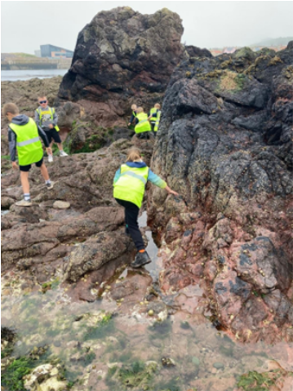
School transport
Where possible we actively encourage
children to walk to school. In addition
to the obvious health and environmental
benefits of walking, reducing vehicle
numbers in the vicinity of the school
improves safety for pedestrians.

Children are encouraged to cycle/scooter to school and use the provided bike stands. It is mandatory that all children wear a bike helmet when riding their bike or scooter to school.
There should be no cycling in the school grounds during or after school hours.

School trips
Throughout the school year the children
participate in a number of school trips which aim to enhance their knowledge and understanding of the world and bring their learning to life.
These outings are subsidised as much as possible by our school fund or parent council but the pupils may be asked to pay part of the cost. We ask parents to support us in this as all outings are carefully planned and highly relevant to the children’s educational experience

Parental permission will be sought
for trips outwith Eyemouth and requiring transport. A letter giving details of the trip will be emailed to parents prior to the event.

Permission forms must be completed online via the Parents Portal, by the stipulated deadline, or we are not permitted to take the child on that trip.

Scottish Borders Council ensure
insurances are in place. In line with
Scottish Borders Council procedures,
Risk Assessments are completed for all excursions.


At the beginning of the new session a letter and from will be sent home for parents/carers to complete for every child. This covers all Local Excursions in and around Eyemouth. The consent form needs to be completed and returned to school.

Terms and Attendance

Terms and Holidays 2026/27
Autumn Term Summer Term
Monday 17th August Tuesday 22nd December Monday 19th April
Staff resume (inservice day) Last day of term for all All resume

Tuesday 18th August Winter Term Monday 3rd May
Staff inservice day Wednesday 6th January May Day holiday school closed All resume
Wednesday 19th August Tuesday 4th May
All resume Friday 5th February Staff resume (inservice day)
Last day for pupils
Friday 9th October February holiday Wednesday 6th May
Last day for pupils and staff All resume
mid term holiday Monday 15th February
Staff resume (inservice day) Thursday 1st July
Last Day of Term
Monday 19th October Tuesday 16th February
Staff resume (inservice day) All resume

Tuesday 20th October Friday 26th March
Pupils resume Good Friday Holiday school closed

Monday 30th November Friday 2nd April
St Andrew’s Day Holiday Last day for pupils and staff

Tuesday 1st December
School closed - Local holiday

Wednesday 2nd December
All resume

Attendance
Good attendance is vital to the success of our young people’s education. Statistical evidence suggests that there are links between attendance levels and pupils attainment. Society in general, and parents and schools in particular, have central roles to play in encouraging positive attitudes to education in young people.
Absence or Other Change in
Circumstance
If your child is absent or there is any change in your personal circumstances
(e.g. change of address) please inform the Primary School Office. It is important to let us know why a child is absent so that school records can be kept up to date. Children arriving late are recorded as such. A phone call or Groupcall message will be sent to parents if a child does not arrive in school and there is
no explanation.

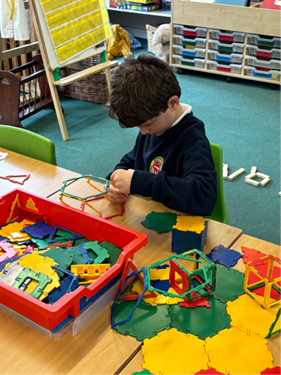

School meals
School meals are prepared in our kitchen. School meals are free for Primary 1 to Primary 5 Pupils. Primary 6 & 7 the cost is £2.90 per meal. Menus are available on the Parent Pay website:
www.parentpay.com
To help reduce food waste, we
encourage parents/carers to involve
their child in the lunch choices.
Tuck Shop
Pupils can bring in money to buy a snack for morning break at our Healthy Tuck Shop
–20p for a piece of fruit.
Breakfast Club is open from 08.00
until 08.35am, £1 is charged and must be booked 24 hrs in advance on the Parentpay website.


Holiday Absences

When a child is to be absent from school a letter should be sent to the Headteacher to explain the reason for absence. It is also acceptable for a parent to telephone the school to say why the child is absent. Only in exceptional circumstances where it is “important to the well-being and cohesion of the family following serious or terminal illness, bereavement or other traumatic events” or where a parent’s employment is of the nature where school holiday-leave cannot be accommodated (for example emergency or armed services) may holidays in term time be authorised. Family holidays where the school does not agree that there is a satisfactory reason for absence will be classified as unauthorised. The school will generally not provide work in advance of teaching, children will be required to catch up
on work missed (where appropriate) on their return to school. The Scottish Office has informed schools that any unexplained absence should be treated as an unauthorised absence that is truancy.

Medical Care

Minor injuries are treated by school staff with basic first aid training. Where professional medical treatment is considered necessary, parents will be informed by telephone and offered the opportunity to accompany their child to the doctor or hospital. If neither parent nor emergency contact can be reached, the Headteacher/Depute Headteachers will see that the child is taken for medical help; parents will be advised as soon as possible. When a child becomes unwell at school and is unable to complete his/her studies, parents will be informed and asked to collect the child from school.

Medical Examinations
The Eyemouth Cluster Schools share a School Nurse. The roles and responsibilities of the service revolve around the health needs of school age children and their families.

The school nursing service is involved in areas of health promotion and improvement for individuals, groups and their school communities. This may include classroom activities and lessons, small group work, presentations and 1:1 work as well as working with education staff and families.

Topics delivered include, drugs and alcohol, sexual health, nutrition, promoting good mental health, hygiene and infection control.

Children and young people are seen as part of the National Child Health Surveillance programme which currently involves growth and selective vision screening for School Entrants and health promotion work with Primary 7 children to facilitate transition to secondary school.

Working with medical colleagues in Child Health, the nursing service takes referrals and reviews school aged children for differing health problems from mental health issues to obesity.

The Education staff use the service for training for the administration of complex medicines and help and advice on general health issues.
AN EMERGENCY
TELEPHONE NUMBER
MUST BE LODGED
WITHIN THE SCHOOL
AND THE SCHOOL
MUST BE INFORMED
OF ANY CHANGE OF NUMBER.
MUST BE LODGED
Medicines
Occasionally children may need to take medicine during the school
day. The only medicine that can be administered by school staff must
be prescribed by a doctor and can only be administered on completion
of the ‘Parental Request for Medicine to be Administered’ by a
parent/carer. This is to safeguard the interests of both staff and pupils.
It is the parent/carer’s responsibility to hand in and collect the
medication to and from the school office.

The Office Staff will keep any medicine in the office.
In some cases, where children have complex medical needs, an Individual Health Care plan will be devised in collaboration with relevant health professionals, staff and parents.
Inhalers are often used and instructions regarding usage must be made clear to us and to your child. Staff are not responsible for the administration of these but will help and support when needed.

In summer time we strongly advise that you send your child to school with a hat and sun cream already applied. Please note school staff are not permitted to put sunscreen onto children.

Head lice: Please ensure that children are checked routinely for this and treat using appropriate chemical and mechanical (nit comb) preparation.

Communicable diseases (see table below)
Recommended minimum periods of exclusion from school of children who are cases or contacts of infectious diseases:
Please could parents ensure that children do not return to school after a period of illness until they are fully recovered.BE INFORMED
OF ANY CHANGE OF
DISEASES | PERIODS OF EXCLUSIONS
Whooping Cough  Influenza | 21 days from outset  Exclusion until clinically well
Measles | Until at least 5 days after the rash appears or clinically well, whichever is longer.
Chickenpox / Scarlet Fever  German Measles (Rubella) | 5 days from onset of rash or until spots become dry – whichever is longer.  5 days from onset of rash.
Mumps | Until swelling subsides
Polio/diphtheria/typhoid/  dysentery/food poisoning/  salmonella  Salmonellosis | Until certified as fit to return by Community Medicine  Specialist (minimum 48 hours)  Minimum of 48 hours after clinically well.
Erysipelas/scabies/ringworm | Until treatment is initiated by a GP/Nurse.
Viral Hepatitis | 7 days from onset of jaundice.
Hand, Foot and Mouth | Exclusion whilst clinically unwell and until spots are healing.
Impetigo  Roseola Infantum (exanthema  subitum) – viral infection | Exclusion until the sores are healed (not weeping) or given effective antibiotics for a minimum of 48 hours.  Exclusion until clinically well.
Scarlet Fever | Exclusion until clinically recovered or 48 hours after appropriate antibiotics have started.
Conjunctivitis  Herpes (Zoster) | Exclusion until symptoms are resolved or as directed by GP.  No exclusion if blisters can be covered; otherwise, for 5 days after onset.
‘Slap Cheek’ (Fifth disease) | Exclusion until clinically well
Vomiting, Diarrhoea and  Fever | May return to school after 48 hours free from last bout of vomiting and diarrhoea.

SEASES PERIODS OF EXCLUSION
.
Policies and Procedures

Health and Safety
Emergency Procedures. If your child feels ill during the school day and we feel that he/she would be better at home, we will telephone you or your
emergency contact. Minor accidents, e.g. cuts, bruises, are dealt with by the school staff. Serious accidents are few, but should one occur your child will be immediately taken either to your doctor or to hospital, if necessary, and you or your emergency contact will be notified. We cannot stress enough the importance of supplying the school with
the relevant information we require in such a situation, i.e. your own home and work number and a telephone number of an emergency contact.
We will request such information at the beginning of each new school year.

Every year, the school publishes a School Improvement Report providing all stakeholders with a comprehensive summary of the school’s work and learners’ achievements over the last year. The first part of this report provides an overview of the school’s progress in addressing its key priorities, while the second part gives information about, for example, how well pupils are learning and achieving; how well the school is supporting children/young people to develop and learn. We also publish a
School Improvement Plan which outlines the key priorities for the school during the year ahead, following due consultation with staff, pupils and
parents. The plan indicates the expected impact of priorities on pupil learning, as well as providing brief
information about the key tasks to be taken forward. Both the report and the plan are available in hard copy on request.
SCHOOL IMPROVEMENT PLAN AND PRIORITIES

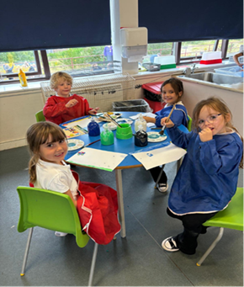
Emergency closure of the school/
adverse weather
In the event of an emergency arising
whereby it is necessary to close the school, you will be contacted by ‘EduSpot’ which is a text message to your mobile phone.
It is the parents’ responsibility to inform the school of any changes to your contact details. If you know that your mobile phone does not have a signal, or you do not have a mobile phone, please inform the School Office so that they can record an alternative landline number to contact you on.

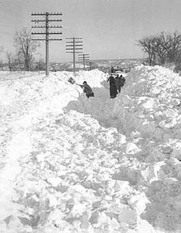
4. School transportation may well be delayed due to adverse weather so pupils will have to wait longer and be exposed to the cold.
5. Children are warmly dressed just in case the journey to school is very slow or even halted in bad weather. In normal circumstances, pupils should not wait more than 15 minutes if the bus is late. In severely cold weather, this 15 minute rule need not apply.
6. If your child travels to school on connecting services, drivers will be told to wait for each other and not to leave any children standing in adverse weather conditions. Should the second bus not arrive children will be returned home. If the second bus does arrive but cannot complete the journey to school that driver will return children to their homes.

Pupils will not be allowed to leave the school unaccompanied unless school staff are satisfied that there is someone at home to receive them.

Severe Weather
In the event of severe weather we will make every effort to keep the school open and continue as normal. However, there may be situations where this is not possible and it is therefore important that you follow the points below in terms of transport arrangements.

During adverse weather, school transport may be subject to cancelled services, amended routes, longer journey times or alternative bus stops used. In extreme cases there may be the need to cancel all school services.

Morning Journeys
- School bus drivers and operators have complete discretion to cancel or vary school transport given any local weather conditions.
- In the case of morning journeys to the school, the driver may decide that he/she either cannot undertake the journey or complete the trip to school. The driver would then return the children home. In the event of adverse weather conditions, parents should ensure that some arrangement has been made at home to cover this possibility.
- Should the school transport for your child not operate in the morning because of adverse weather conditions but you decide to take your child to school yourself then you are expected to collect your child either at the end of the school day or at the time of early closure. Do not bring your child to school when buses do not run unless you are certain of being able to collect them at the end of the school day – even if the weather worsens.

Additional information to ensure the
safe travel of pupils to/from school
12. The ultimate responsibility for the safety of children walking to and from bus pick-up/drop-off points rests with the parents. Parents must decide whether or not children can make their way to meet transport in low temperatures.
13. If you feel that your child should not walk home alone in bad weather from the drop-off point it will be your responsibility to meet him/her. Drivers will not normally set children down at any point significantly different from the usual one. The driver will use his/her judgment in deciding whether to leave the child or to keep him/her on the bus. In the latter case, your child would be taken to a nearby school or place of safety. Children must follow any instructions given to them by the driver in any emergency and should not leave the bus to make their own way home.
14. Where transport is unable to operate to take children home as a result of extreme weather conditions The Emergency Planning Team will work alongside our partners to provide alternative and safe transport home.

Arrangements have been made with Radio Borders to relay information about the cancellation of school transportation and group call and Scottish Borders Website will be used to inform parents of any important information.

What will happen if pupils are sent
home early due to bad weather or other
emergency?
7. The Headteacher with knowledge of local weather conditions will work with the Education Department to make decisions regarding a school closure or to send children home early should severe weather conditions threaten.
8. Where pupils use school transportation a set of emergency instructions are used to contact transport operators and other schools using the same transport, and parents whose children have a long way to walk home from the drop-off points. Parents must ensure that some arrangement has been made to cover the possibility of pupils being sent home early.
9. Schools routinely communicate with parents or groups of parents using Groupcall text messaging service. Once the decision has been made then Group call will be used to send updated information regarding sending pupils home early.
10. Parents are asked to ensure that the
school that their child attends has
an up to date and accurate mobile
telephone number on record for these purposes. It is further suggested that parents who may find it difficult or not possible to have their mobile telephone switched on throughout the day ensure that they check their phone on a regular basis for any Groupcall messages from the school when bad weather has been forecast or where they see deterioration in the weather.
11. If school transport is in operation
and you collect your own child from
school during severe weather then the school office must be informed so that transport is not delayed while staff look for a missing child.
Policies and Procedures
Use of the Internet
As part of the process of learning we allow our children supervised access to the Internet and email. The authority runs its own filter system to ensure that young people are not at risk from exposure to inappropriate material.
This filtering system is regularly being upgraded. We have a policy for use of the Internet and a contract for responsible use, which we ask parents and young people to sign up to.

Photographs and videos may be taken by staff in the school, media and other parents for a variety of reasons for example Sports Day, celebrations of achievement, charity events, excursions etc. The school your child attends may wish to display or show photographs or videos taken by themselves, in print, in various locations or by electronic means such as a website. Likewise the media or other parents may wish to use the images of pupils in various
ways. We ask you at the time your child enrols at one of our schools if you are happy for images of your child to be used in this way and we try to ensure you are aware of, and understand, such possible use of your child’s image and that you have consented.

Any permission given will remain in force during your child’s primary and secondary schooling until you indicate that you wish to withdraw your consent. You can do this by contacting the Headteacher of your school as soon as possible.

PHOTOGRAPHS/VIDEOS

Security
In the interests of school security external doors are kept locked while pupils are in class. Parents requiring access to the school should press the entry button at the Main School Entrance or Nursery Entrance. All visitors must report to the office to sign
in the visitors book and collect a visitors badge, which should be returned at the end of the visit.

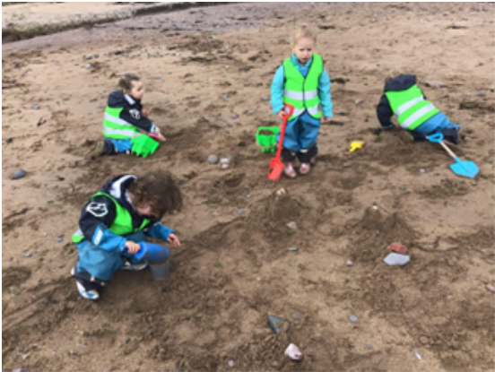

Policies
There are a number of National, Education Services and school policies which will
provide information on a range of issues.
Further details of all of these are available
from your school or on the Scottish Borders Council website www.scotborders.gov.uk

Child Protection

Keeping our children and young people safe in the Scottish Borders

- Our settings in the Scottish Borders work hard to keep our children and young people safe - all children and young people have a right to feel safe within the setting, home and community.
- Within our setting we strive to provide a safe, secure and nurturing environment for our children and young people, which promote inclusion and achievement.
- All staff in Education have a statutory and professional responsibility to take action if we have reason to believe a child is suffering, or is at risk of abuse.
- Scottish Borders Child Protection procedures (http://onlineborders.org.uk/community/cpc) set out what we will do if we have reason to believe a child is being abused or is at risk of
- abuse, either within the home or the community. These procedures are designed to ensure that children and young people get the help they need when they need it.
- All staff are aware of their child protection responsibilities and every year all staff in our setting attend a child protection update.
- Many of our staff undertake additional multi-agency child protection training.
- Every setting has a Child Protection coordinator who has the responsibility for overseeing child protection concerns as well as those young people who are care experienced within the setting.
- The Child Protection co-ordinator for Eyemouth Primary School is: Scott Agnew, Depute Headteacher,
- Deputising Child Protection Co-ordinators are: Jill Horsburgh, Headteacher and Liz Hiroz, Depute Headteacher

What to do if you have a child protection concern? (www.scotborders.
gov.uk/childprotection)
It’s everyone’s responsibility to protect children. If you have any concerns that a child
is being harmed or is at risk of harm, please call without delay
01896 662787 (Duty Children and Families Social Work Team)
01896 752111 (Out of office hours that covers all areas)

Emergency contact
If you consider a child or young person is in immediate danger, call the Police on 999 immediately

Need more information about keeping our children and young people safe?
This link (http://onlineborders.org.uk/community/cpc) takes you to the Scottish Borders Child Protection Committee online website where you can find some suggested links to websites to better inform you about safety issues such as Internet safety and Child Sexual Exploitation as well as letting you know about opportunities for training in Child Protection. You can also find the Scottish Borders Child Protection Procedures on this website.

http://onlineborders.org.uk/community/cpc

Young Carers

- Detailed information about the Carers Act 1.4.18 is available on the Scottish Government website (https://www2.gov.scot/Topics/Health/Support-Social-Care/Unpaid-Carers/Implementation/Carers-scotland-act-2016)

- More information about the Scottish Borders Young Carers Service is available from the Action for Children website
(www.actionforchildren.org.uk/what- wedo/
our-work-in-scotland)

- The Partnership’s Locality Plans are
available at: www.scotborders.gov.
uk/HSCPLocalityPlans


A young carer is someone who is under 18 years of age or who has reached 18 and still a pupil at school and provides or
intends to provide care for another individual. A number of young carers do
not always identify themselves or wish to
be identified.

Young carers undertake a number of tasks for the people they live with and
look after. They are often left alone to do
things like washing, cooking, shopping,
paying bills, collecting medication or
helping to look after younger brother or
sister.

This means they might not have as much time to complete work at home which has an ongoing effect on progress and learning or attend clubs and after schools activities therefore missing out on the social aspects of school or their local community.

Within Eyemouth Primary School we want our young carers to enjoy school and that it is a positive place to come and they feel included.

Please let us know if there are difficulties for your child in meeting homework deadlines, arriving on time or any other issues which may affect their wellbeing at school. It is the intention of Eyemouth Staff to offer all support they can to your child.



Data Protection

Scottish Borders Council is a local authority established under the Local Government etc.
(Scotland) Act 1994 and its headquarters is based at Newtown St Boswells, Melrose TD6
0SA. You can contact our data protection officer by post at this address, or by email at:
dataprotection@scotborders.gov.uk , or by telephone 0300 100 1800.
• The Scottish Government (https://
www2.gov.scot/Topics/Statistics/
ScotXed/SchoolEducation/
ESPrivacyNotices) for examination,
career guidance and monitoring purposes.
• ParentPay, ESP Systems and CRB to
allow the school to offer cashless
catering and to receive payment for
school trips and events;
• Groupcall to allow the school to
communicate with you;
• The NHS for health monitoring;
• Netmedia to enable the online
arrangement of parents evenings;
• Internal Scottish Borders Council
departments to allow the provision of
catering and transport.
On each occasion, the recipients are
bound to the terms of a Data Sharing
Agreement and accordingly will only
use your child’s data for the specified
purpose.
This data sharing is in accordance with
our Information Use and Privacy Policy
and covered in our full privacy statement
(https://www.scotborders.gov.uk/info/20060/access_to_information/877/privacy_statement/9) on our website.
We are also legally obliged to share certain data with other public and regulatory bodies such as Education Scotland, Police and NHS will do so where the law requires this.
Your information may also be shared and analysed internally in order to provide management information, inform service delivery reform and similar purposes to meet our duty to achieve best value and continuous service improvement.
We are legally obliged to safeguard public funds so we are required to verify and check your details internally for fraud prevention. We may share this information with other public bodies (and also receive information from these other bodies) for fraud checking
purposes.

Why we need your information
Every child of school age has the right to be educated. A child is of school age if he/she has attained the age of 5 but has not attained the age of 16 years. The term “young person” applies to a pupil over school age, but who has not attained 18 years. The education authority has a duty to provide education to any young person who is still a school pupil. We need to collect, use and store personal information about you and your child/ren to enable us to provide your child/ren with an appropriate education. We provide these services to you as part of our statutory function as your local authority under:
• The Education (Scotland) Act 1980,
Education (Scotland) Act 1980
• The Education (Placing in Schools
etc. Deemed Decisions) (Scotland)
Regulations 1982
• The Standard in Scotland’s Schools
Act 2000
• Education (Scotland) Act 2016

We also use your information to verify your identity where required, contact you by post, email or telephone to maintain our records.

Who we will share information with
We will share information with health and wellbeing services and may share
information with other external agencies and organisations who provide or assist with educational provision and with online payment solution providers.

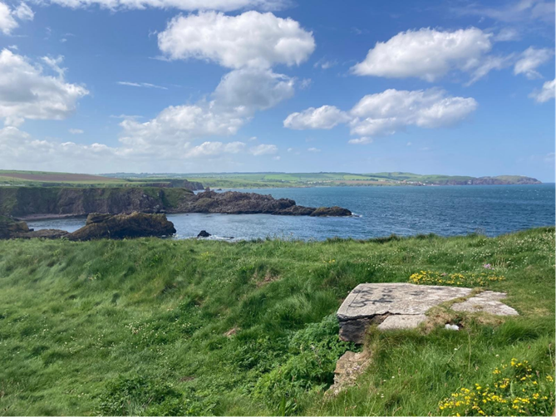

USEFUL LINKS:
www.scotborders.gov.uk
www.education.gov.scot
www.parentpay.com
www.liveborders.org.uk
www.unicef.org.uk/rights-respecting-schools

We aim to directly resolve all complaints about how we handle personal information.
If your complaint is about how we have handled your personal information, you can contact our Data Protection Officer by email at: dataprotection@scotborders.gov.uk
or by telephone on 0300 100 1800.

However, you also have the right to lodge a complaint about data protection
matters with the Information Commissioner’s Office, who can be contacted by post
at:
Information Commissioner’s Office, Wycliffe House, Water Lane, Wilmslow, Cheshire, SK9 5AF.

You can visit their website for more information https://ico.org.uk/make-a-complaint

If your complaint is not about a data protection matter you can find details on how to make a complaint on our website: https://www.scotborders.gov.uk/info/20016/have_your_say/155/make_a_complaint/1
COMPLAINTS
We are legally obliged to safeguard public funds so we are required to verify and check your details internally for fraud prevention. We may share this information with other public bodies (and also receive information from these other bodies) for fraud checking
purposes.

How long do we keep your information for?
We only keep your personal information for the minimum period amount of time necessary. Sometimes this time period is set out in the law, but in most cases it is based on the business need. We will retain a copy of your child/ren’s educational record up
until they reach the age of 25.

Your Rights
You have the right to request access to
any personal data held about you by the Council. You can also request that we restrict the use of your information or even object to any further processing. You can do this by contacting the Data Protection Officer using the contact details provided
above. We will respond to your request
within thirty calendar days.
For more information on your rights please visit our website http://www.uk/DPYourRights or if you would like a hard copy of this information, please contact us using the contact details provided above.

DISCLAIMER
Whilst information provided is considered to be correct at the time of printing, it is possible that there may be some inaccuracy by the time the document is read and referred to.

